THE CARS: ETL

By: Nathan Higley, Karl Unverferth & Chad Gielow

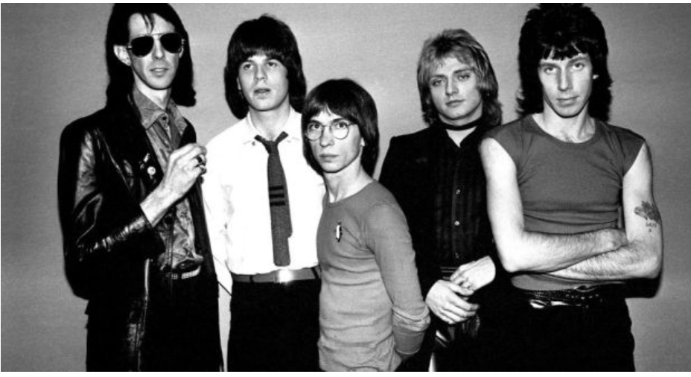

**SUMMARY**

For this project we performed ETL procedures to explore the data around new and used cars and pricing.

**EXTRACTION**

Two data sources were used to build this project, both were captured from Kaggle.com as CSV files. The first file was data related to all used car sales on craigslist across North America. Make, Model, Year, price & links to the posting were all included in the data. The 2nd file was data related to new car sales and included Make, Model, Year & MSRP.

1. Used Car data: cleaned_used_car.csv
2. New Car data: new_cars2.0.csv

**TRANSFORMATION**

Cleaning the data first required us opening the CSV Files in Jupyter Notebook books.

Used Car Data: Dropped Columns, Rename Columns & export as a new CSV

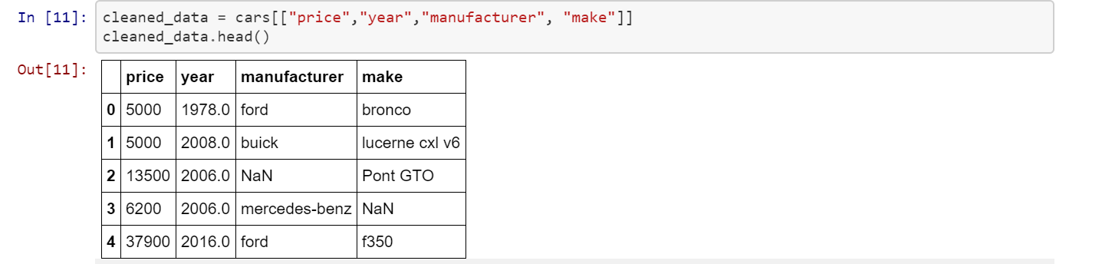

New Car Data: Sorting Data, Dropping Columns

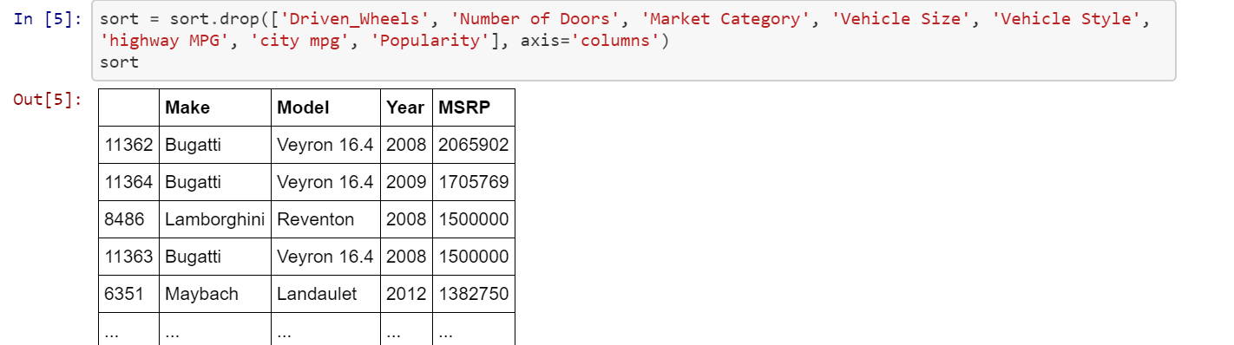

**LOAD**

The last step was to transfer our cleaned CSV Files into a DataBase. The database was created with two tables to match the columns from the CSV files so they could import into the SQL database. Once the data was loaded into the SQL database queries can be ran to answer questions that we have about the value of new and used cars.